- PWD – Present working directory
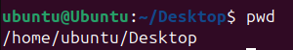
- Cd – Change Directory
Cd/ Root Directory
Cd ~ Home Directory
- LS- List of Files available in Root Directory and Home Directory
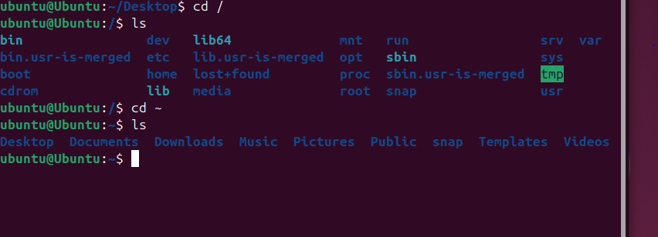
- LL – Long list ( list of file as well as details of files in system )
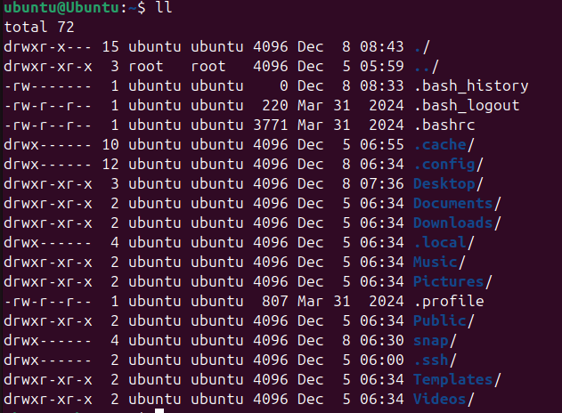
- LS-LTR – Same as Long list ( List of oldest files to newest files )
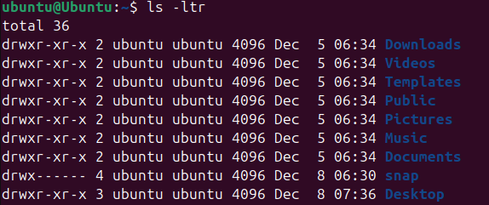
- ls –a :- To get the hidden files
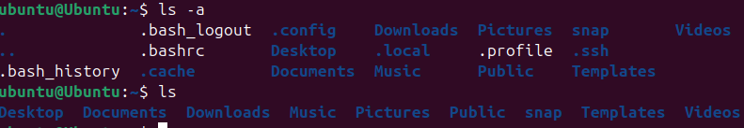
- cd .. :- to go back one step
- cd ../.. :- to go back two step
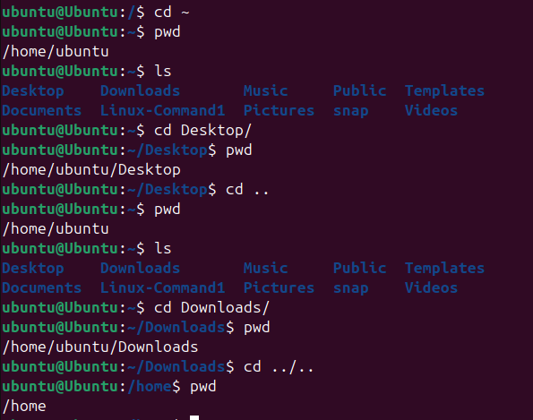
- mkdir – to create one directory
Hide – To hide the file use . infront of file name
Un hide
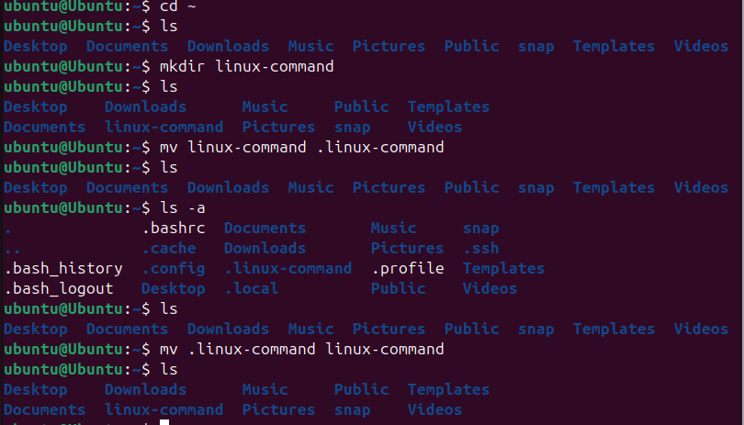
- Delete- to delete directory rm –rf
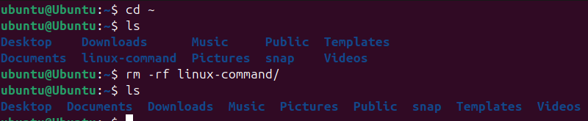
- Move – to move directory to another location use mv
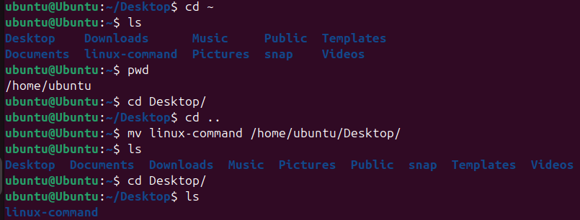
- To copy and past use cp –r
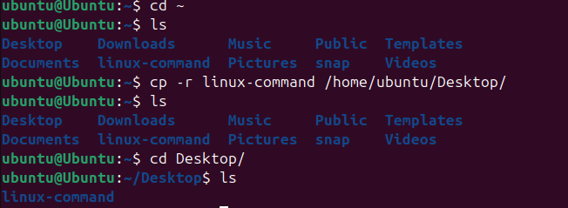
- To create a file inside the documentary use touch
To add the text to the file we can use vi
To enter the text to the file type i
To save the text, type Esc :wq!
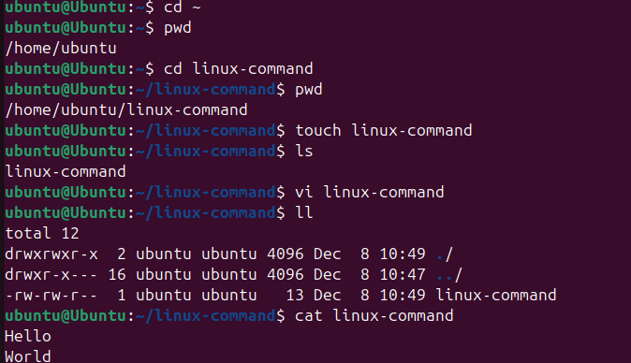
- WC – to read the word count
